Eoin Cowhey eoincowhey@hotmail.com

Certificate in Introductory

Data Analytics

Distribution Power Transformer Online Monitoring

Project Report

# GitHub URL

[eoincowhey/UCDPA_eoincowhey: Certificate in Introductory Data Analytics (github.com)](https://github.com/eoincowhey/UCDPA_eoincowhey)

# Abstract

The purpose of this project is to demonstrate how online monitoring can aid in the change in maintenance strategies of power transformers from time based to more predictive or risk based strategies. Many modern power transformers are coming equipped with online monitoring devices such oil and winding temperature supervision, partial discharge monitors connected to bushing and other gas monitoring devices. By accumulating the data from these devices and looking at load profiles and other statistical data, this can provide Engineers and Power System Operators with valuable information on the health of power transformer. Therefore, allowing them to predict potential issues and failures in advance eliminating costly outages for consumers. Also, maintenance periods can pushed out to only when required, therefore, significant savings can be made here also while increasing the availability of plant.

# Introduction

Power transformers are the single most expensive items in power distribution and transmission substations and in the event of failure can cause significant issues for system operators and customers. Many industrial customers and independent power producers (IPPs) do not have any redundancy in their distribution substations and this potential single point of failure can lead to significant outage time and ultimately loss of revenue. The lead time for delivery of many power transformers in excess of 31.5 MVA can be over a year in length.

For this project, electrical and temperature from a dataset of a small distribution transformer was used to calculate load and temperature data over an 11 month period.

# Dataset

The dataset for this project with data from a small distribution transformer was obtained from Kaggle website (Kaggle, 2020).

This example contained a data set from the LV side of a 3 phase 400 V distribution transformer, the data was collected over an 11 month period from 25th June 2019 to 14th April 2020. The .csv dataset files and variables from these used in the project are outlined in Table 1. The time stamping of data was indicated to be at intervals 15 minutes, however, this was found to be different in the datafiles.

Table : Dataset .csv and dataset variables.

|  |  |  |
| --- | --- | --- |
| **CurrentVoltage.csv** | **Temperature.csv** | **PowerFactor.csv** |
| VL1 – L1 Phase Voltage  VL2 – L2 Phase Voltage  VL3 – L3 Phase Voltage  IL1 – L1 Phase Voltage  IL2 – L2 Phase Voltage  IL3 – L3 Phase Voltage | OTI – Oil Temperature  WTI – Winding temperature  ATI – Ambient Temperature | PFL1 – L1 phase Power Factor  PFL2 – L1 phase Power Factor  PFL3 – L1 phase Power Factor |

It is assumed based on the ambient temperature readings that the transformer is located in a warm environment (possibly indoors).

# Implementation Process

## Real World Scenario

The real world scenario used was the data from the online monitoring of a distribution transformer over an 11 month period (see previous section).

## Importing Data

### API Example

This API is not related to the project, however, this is to demonstrate how APIs can be used to obtain data from online sources. The API displayed here is from the Open Notify API Sever (Open Notify API Server, 2016) as demonstrated in class. In this API once a request is made, the people current in space and the name of their space craft ids displayed. A status request is also made to ensure that the link is operational.

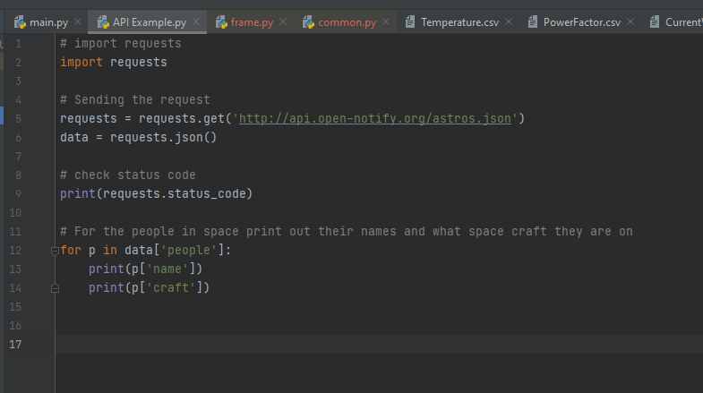

Figure : API example code

### Importing Data

Three CSV files were imported (see Table 1 for details) to the project directory in PyCharm. They were imported via a drag and drop method.

In PyCharm the CSV files were converted Pandas Data Frames using the code outlined in Figure 1.

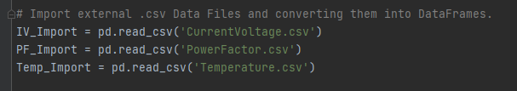

Figure : Converting csv files to DataFrames

## Analysing Data

The data was then analysed to ensure, it was complete with no missing values, this was performed using the code in Figure 2, it was found that there were no missing values. Also, as the Data Frames were going to be merged, the shape of each was also checked using the .shape function to see how many rows would be missing (or don’t align).

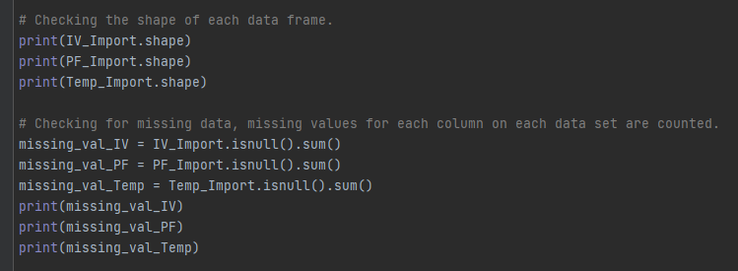

Figure : Finding shape of each data frame and listing any missing values

Before merging the imported Data Frames, duplicate rows based on the times stamp in data frame were removed using the .drop duplicates function sub setting the Device Time stamp.

The unnecessary data columns were also removed from each Data Frame as shown in Figure 4.

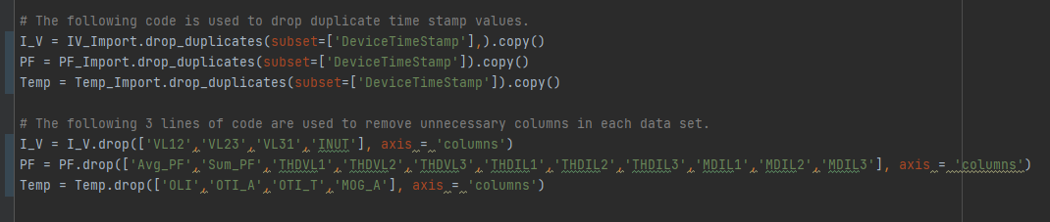

Figure : Removing unnecessary columns from data frames

The current and voltage Data Frame and the Power Data frame were merged together using the .merge function, this was a left merge and on the Device Time Stamp as this was common to both Data Frames, see Figure 5. Further on in the script, the current and voltage Data frame and Temperature Data Frames are merged to estimated the transformer winding temperature.

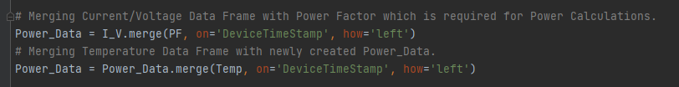

Figure : Merging data frames.

Following merging of data frames it was found that there were discrepancies between the sample times between the Data frames. This was due to different length of the sampling columns, therefore:

* For the power factor, much of the missing data was found during low load periods so the missing data could be assigned as 1 (unity power factor) using the .fillna function.
* With the temperature Data Frames, as actual temperature changes are quite slow in relation to the time stamp intervals, the missing data was forward filled using the .fillna function.

See Figure 6 for details of methods used.

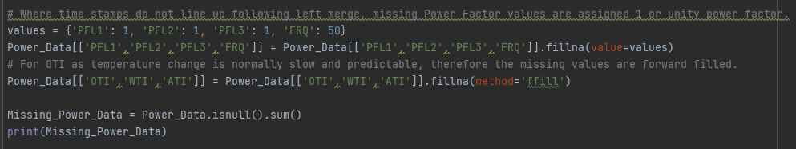

Figure : Filling missing data

To demonstrate looping and iterrows, previously calculated were the active and reactive power for each of the 3 phases of the transformer. Using the itterows function the 3 phase active and reactive power is calculated and converted from watts and vars to kW and kars. Normally it would be quicker to simply perform the calculations across columns as per the single phase quantities, but for demonstration purposes it performed here. Also, a for loop was applied in API example. See Figure 7 below.

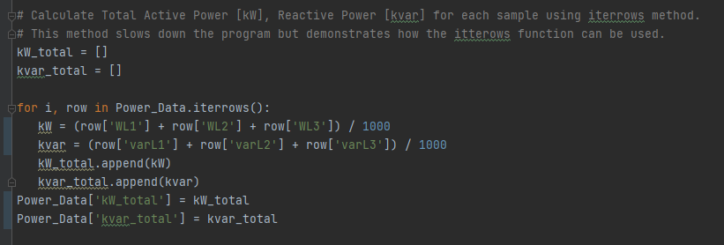

Figure : Itterows

To demonstrate how slicing was performed using the loc function, the example used here to slice all data over the defined period for graphing the transformer oil and winding temperatures over the set range, see Figure 8 below.

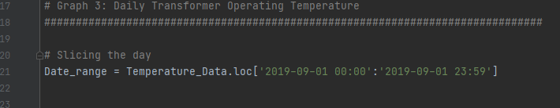

Figure : Loc function

## Analysing Data

Numerous reusable functions were created in this program, examples include:

* Functions were created for calculating the single phase active and reactive powers, see Figure 8 below.

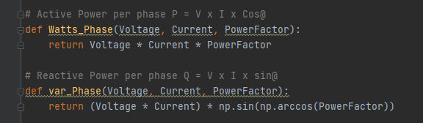

Figure : Active and reactive power functions

* A function was also created for calculation of the secondary winding temperature thermal indicator current transformer, see Figure 10 below.

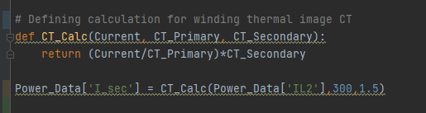

Figure : Thermal image CT calculation

Numpy functions were also used throughout this program, this example shows the analysis of the maximum, minimum and mean active and reactive power loading of the transformer for each month and the oil temperature, winding 2 current and ambient temperature for each month.

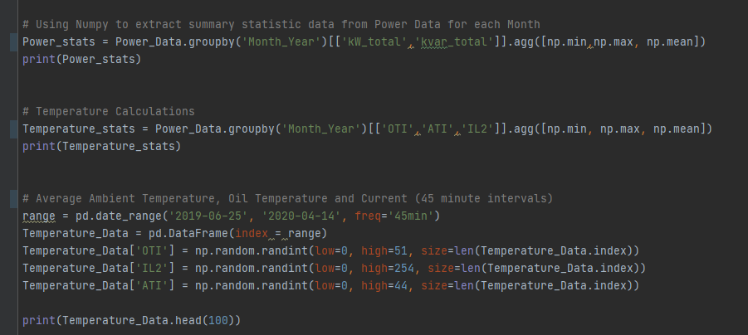

Figure : Numpy

## Visualise

Seaborn was used to create a bar chart for both the active and reactive power loading for each month, see example in Figure 12 below.

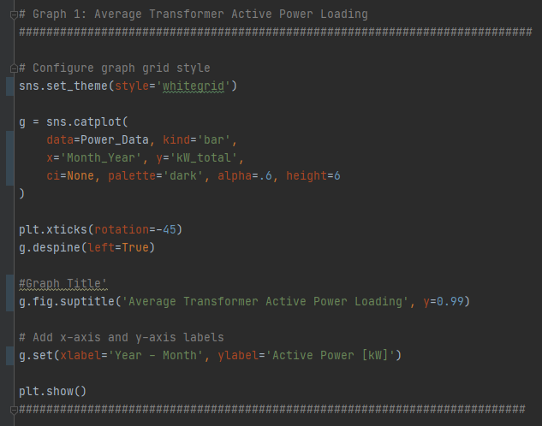

Figure : Seaborn bar chart

Matplotlib was also used to provide a line graph of the daily operating temperatures of the transformer oil and windings, and also the load in relation to the oil temperature. See Figure 13.

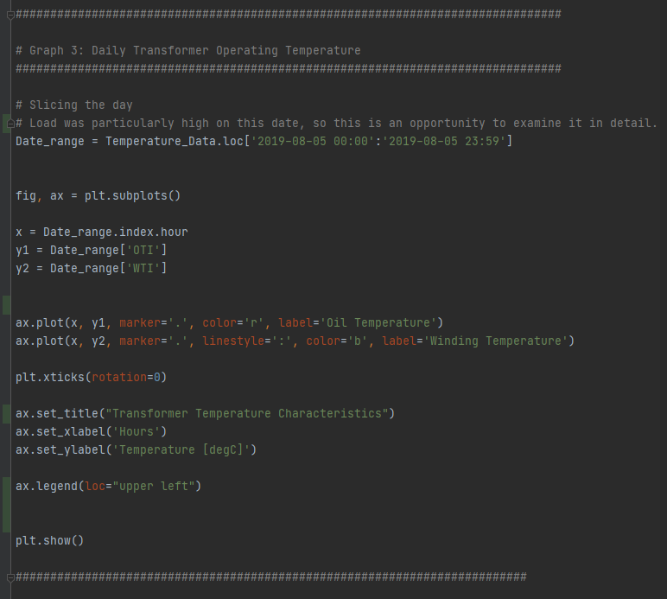

Figure : Matplotlib line graph

# Results

The first graph Figure 14, depicts the average active power loading of the transformer each month over the entire 11 month period. This gives the system operator or power systems analyst a detailed overview of the average load the transformer is supplying. This information would be used to ensure that a transformer is never under stress operationally and also gives indication for future decisions in uprating the transformer if the average energy demand increases.

Figure : Average Active Power Loading

Figure 15 gives an overview of the average reactive power loading by the consumer per month, reactive power is energy used to supply magnetic fields for inductive loads such as motors and transformers and can easily be corrected by installing capacitors. Having a high reactive power component flowing through the transformer does not make efficient use the transformer as it results in a higher current to supply the load. Having this information allows the system operator/ engineer to make decisions on any reactive compensation measures required.

Figure : Average Reactive Power Loading

Figure 16 and Figure 17 give an overview of the temperature characteristics of both the oil and windings under load conditions. The winding temperature is estimated from a non linear graph based on the oil temperature measurement and measured current. Excessive temperature due to overloading can significantly reduce the life of the transformer due to degradation of internal insulating materials and components. Temperature is a key health indicator of a transformer.

Figure : Transformer Temperature Characteristics

Figure : Oil Temperature and Loading Characteristics

# Insights

1. In the first graph Figure 14, the period that the transformer is most loaded is August, September and October. It is lowest loaded month in December is 2/3 of that of the highest month. There is no load indicated in June, from the data recorded there is no voltage which would indicate that the transformer was possibly out of service.
2. In Figure 15, the reactive power loading is quite high in comparison to the active power loading which is an indicator that compensation measures are required. Again as per the active power, the months with the highest recorded active power are August, September and October.
3. It can be seen from the temperature characteristics that the temperature increases with load during possible hours of business, early in the morning and late in the evening the load is low and the temperature drops off.
4. In Figure 16 and Figure 17, it can be seen that the winding temperate follows the oil temperature until load starts to increase, the additional compensation is typically not applied until approximately 45 % of the load current is applied.
5. In Figure 17 it can be seen that the increase in oil temperature typically lags the load, from about 15:00 hrs and 20:00 hrs the decrease in temperature could be attributed to forced cooling.

# References

Kaggle, 2020. *Distributed Transformer Monitoring.* [Online]   
Available at: https://www.kaggle.com/sreshta140/ai-transformer-monitoring

Open Notify API Server, 2016. *Open Notify API Server.* [Online]   
Available at: http://api.open-notify.org/